**Assignment No:09**

**Title: Deploy a project from GitHub to EC2..**

**Step-1:**

Upload required files to github

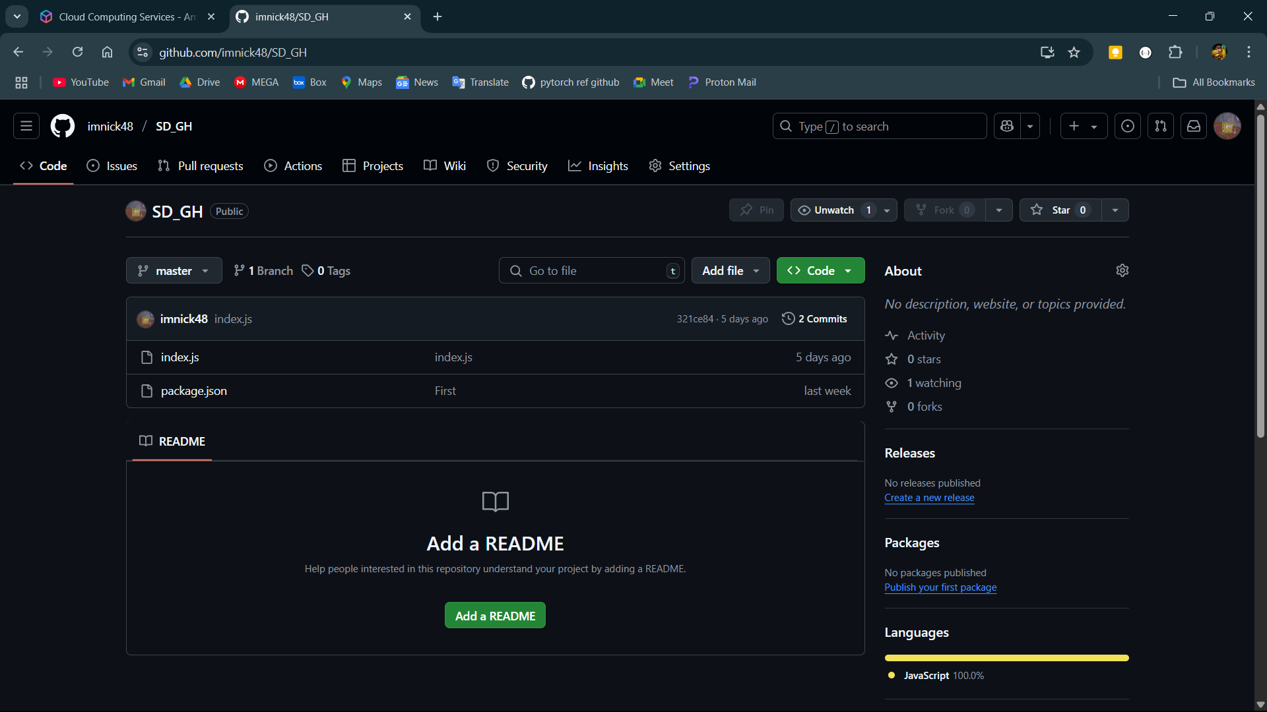

**Step-2:**

Click on the profile icon and open settings then scroll down in the left side and open developer settings then open the token(classic) under the personal access tokens.

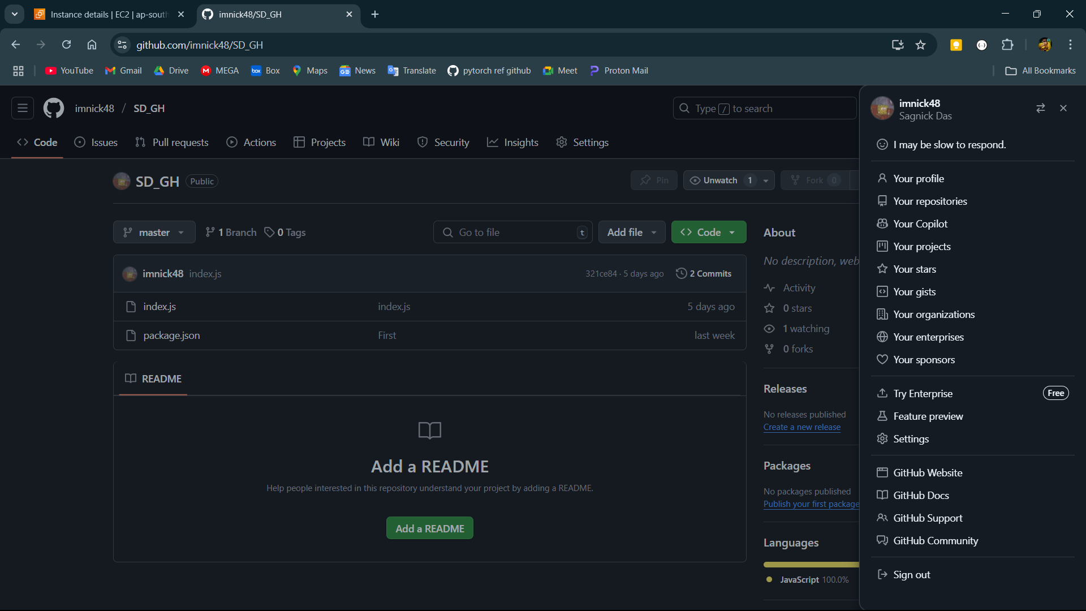

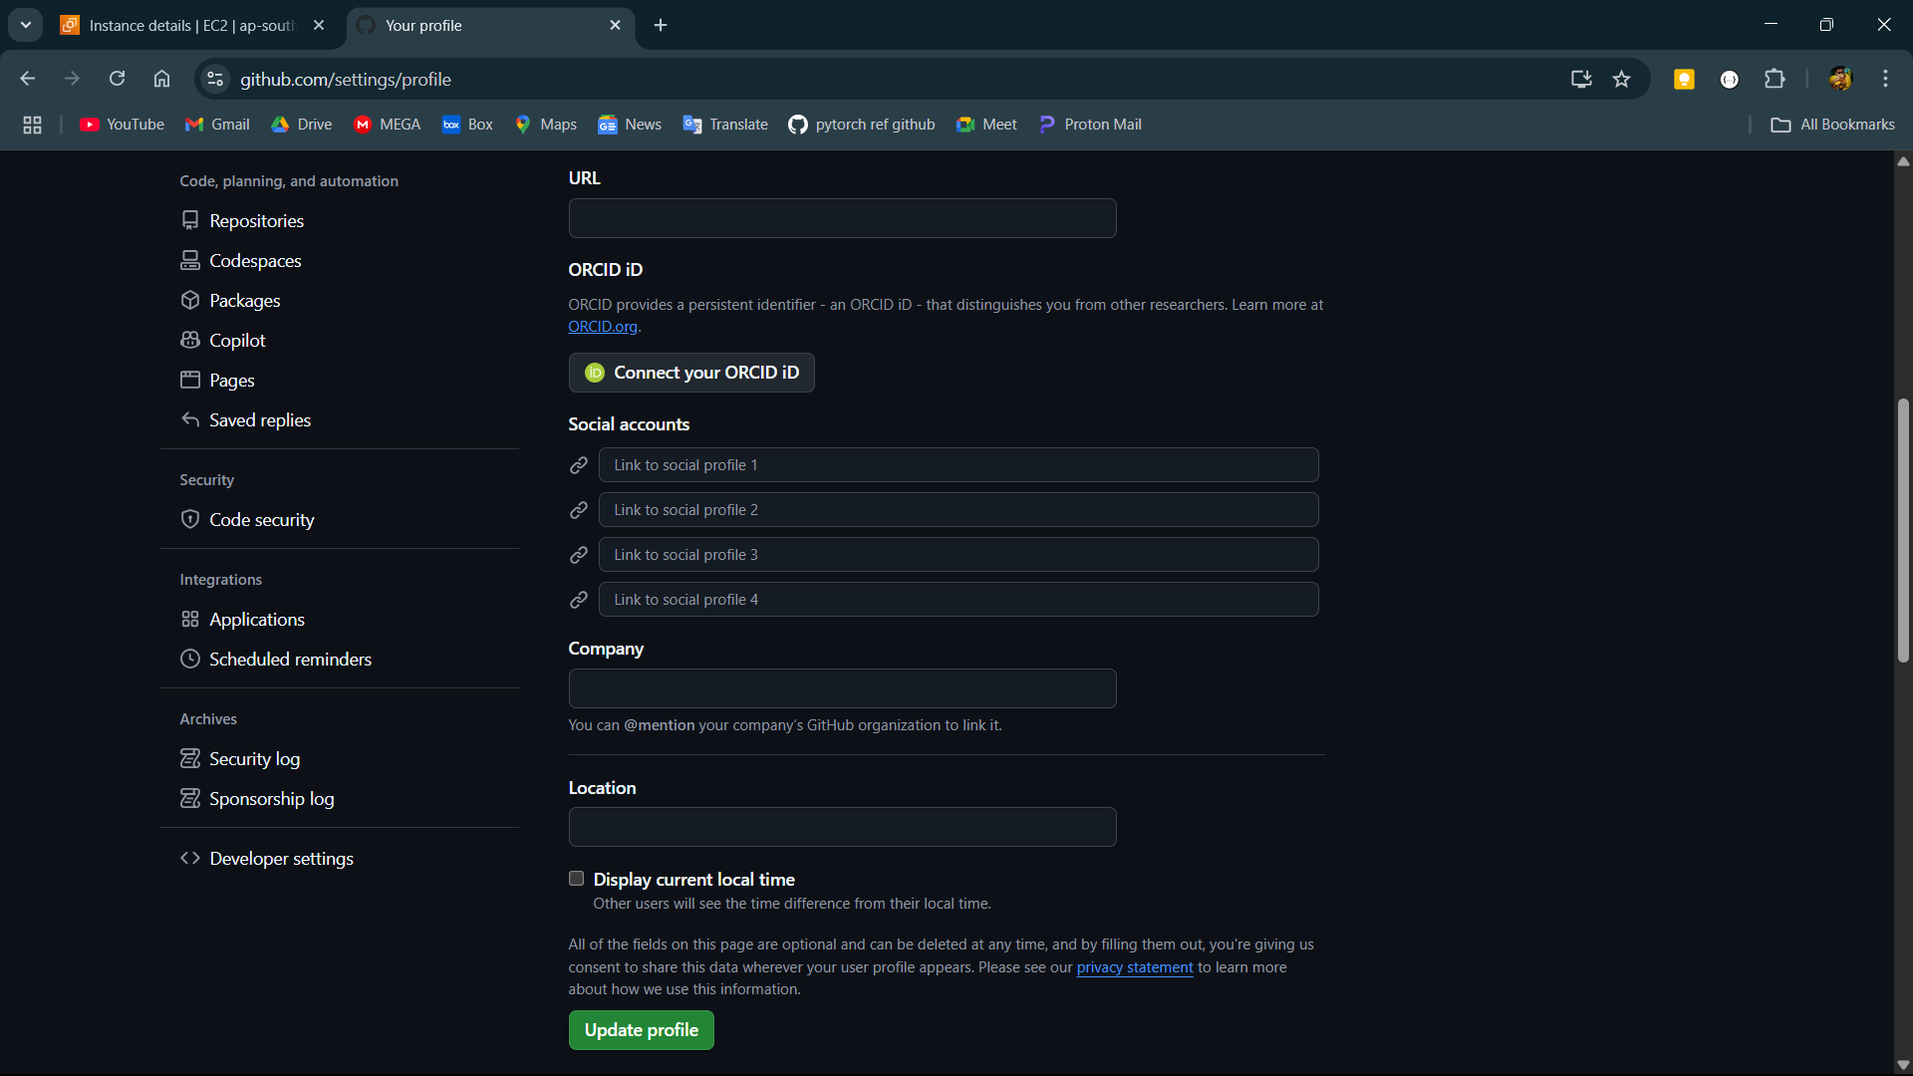

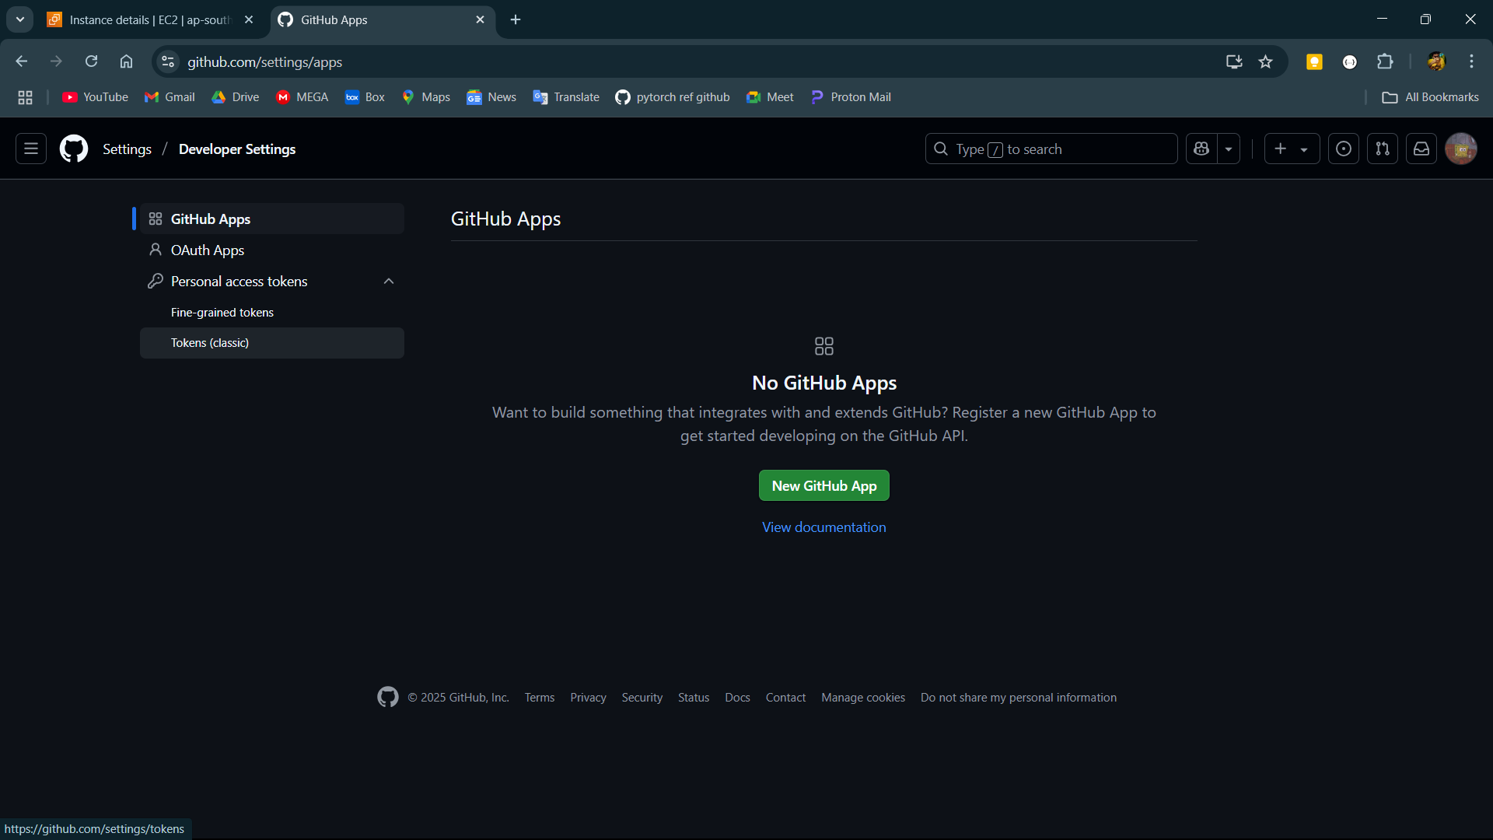

**Step-3:**

Click on generate new token and then click on generate new token(classic).

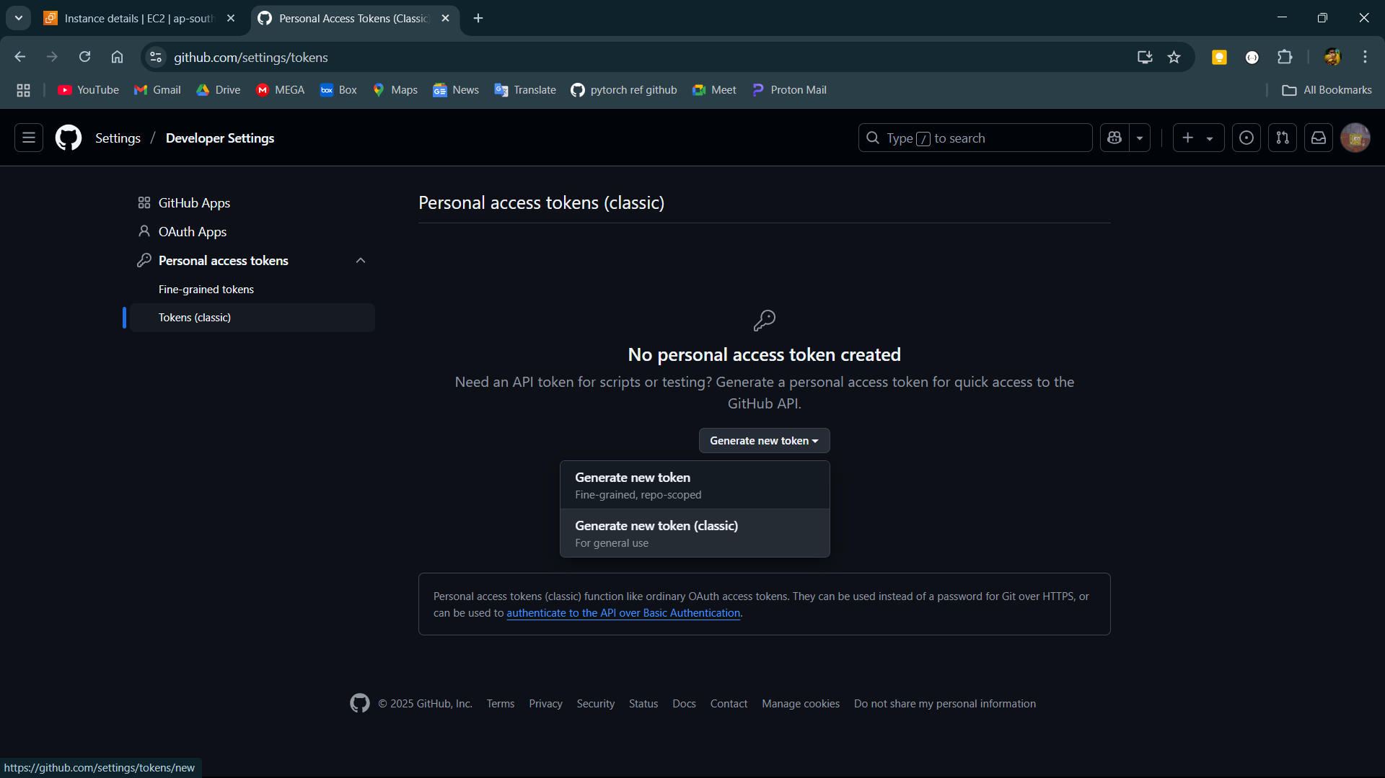

**Step-4:**

Give a name to the token in the note field and check all the scopes and save the token id.

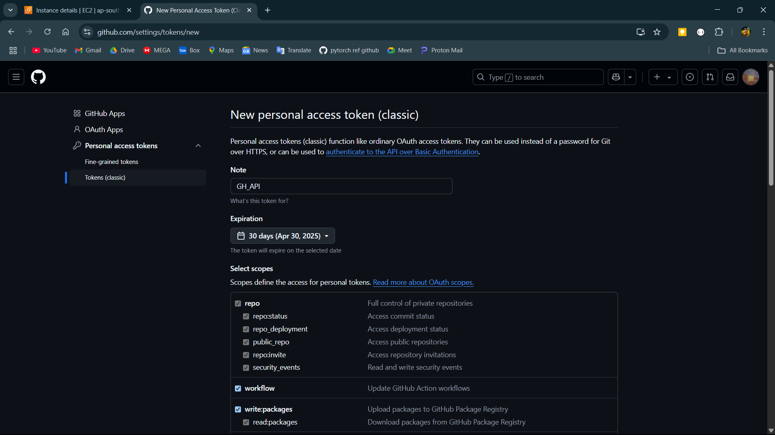

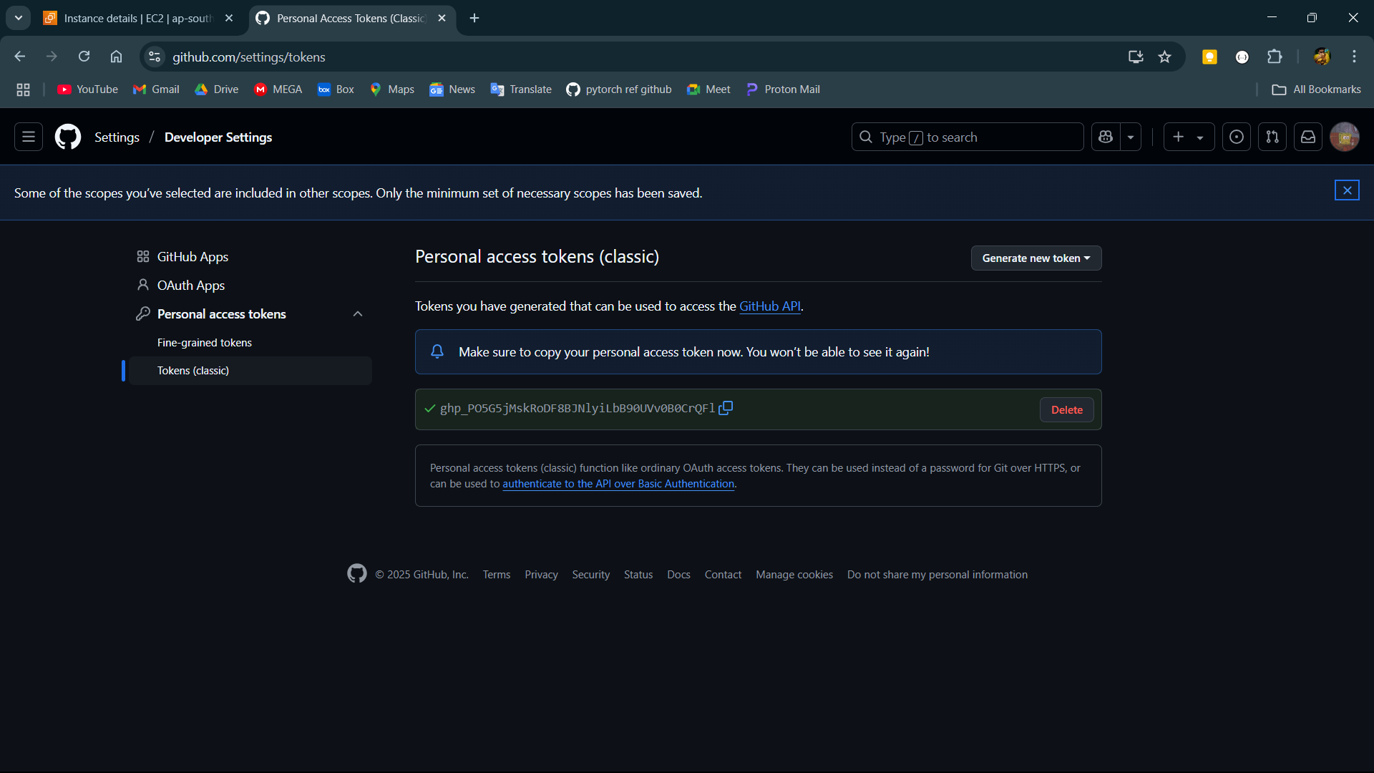

**Step-5:**

Log into AWS and open EC2.

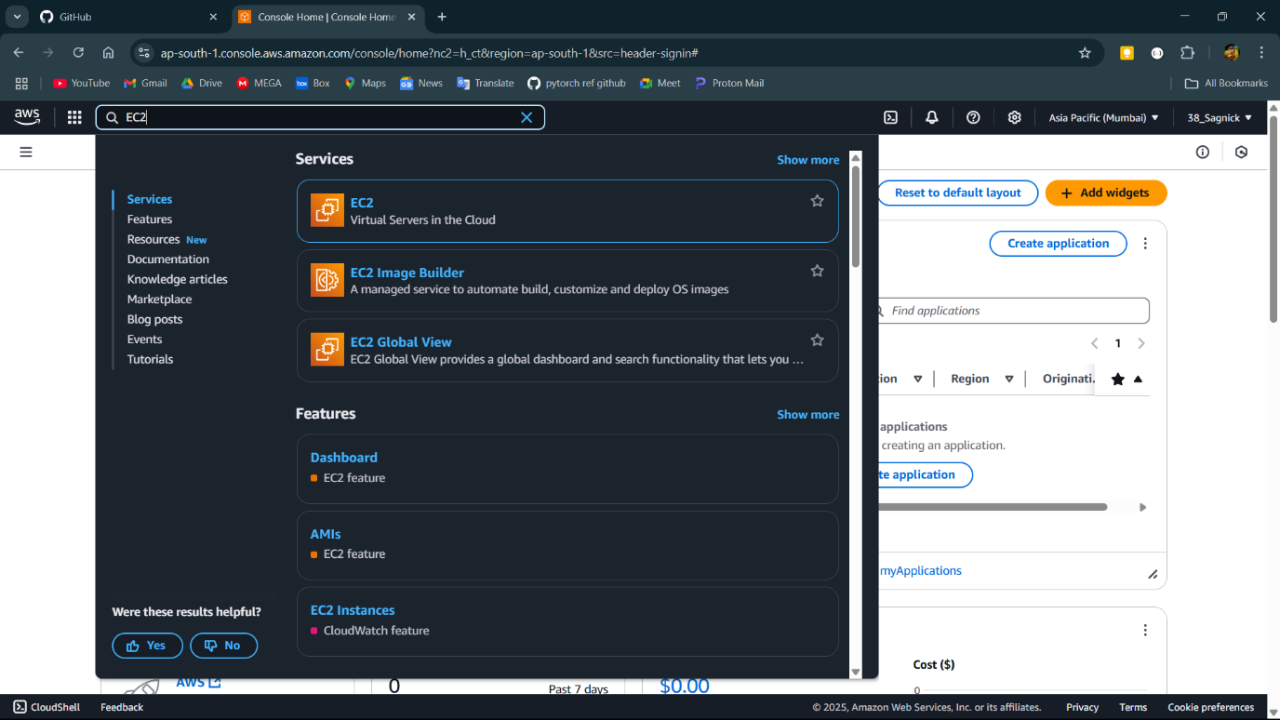

**Step-6:**

Click on launch instance.

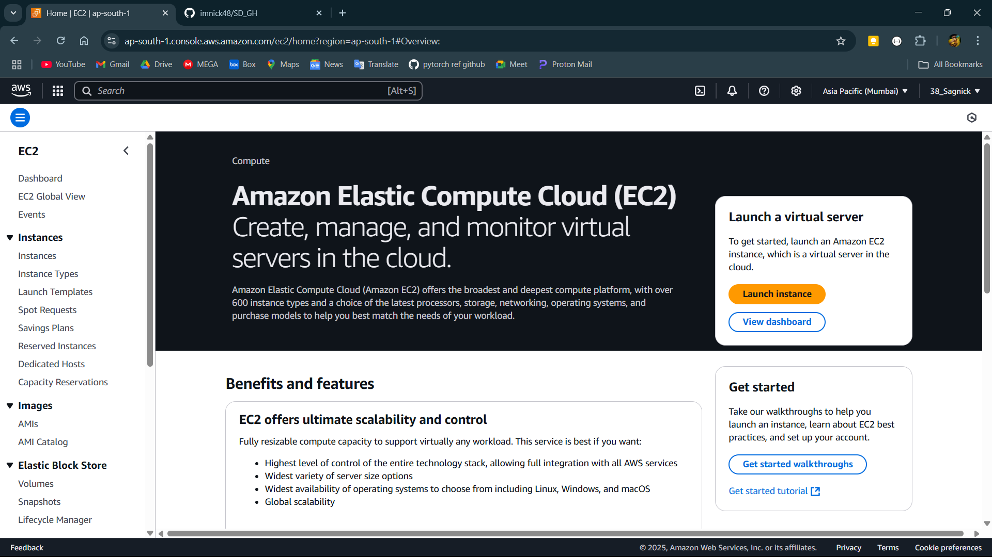

**Step-7:**

Give a name to the instance and select the operating system then check the 3 boxes to allow SSH, HTTP and HTTPS traffics and click launch instance.

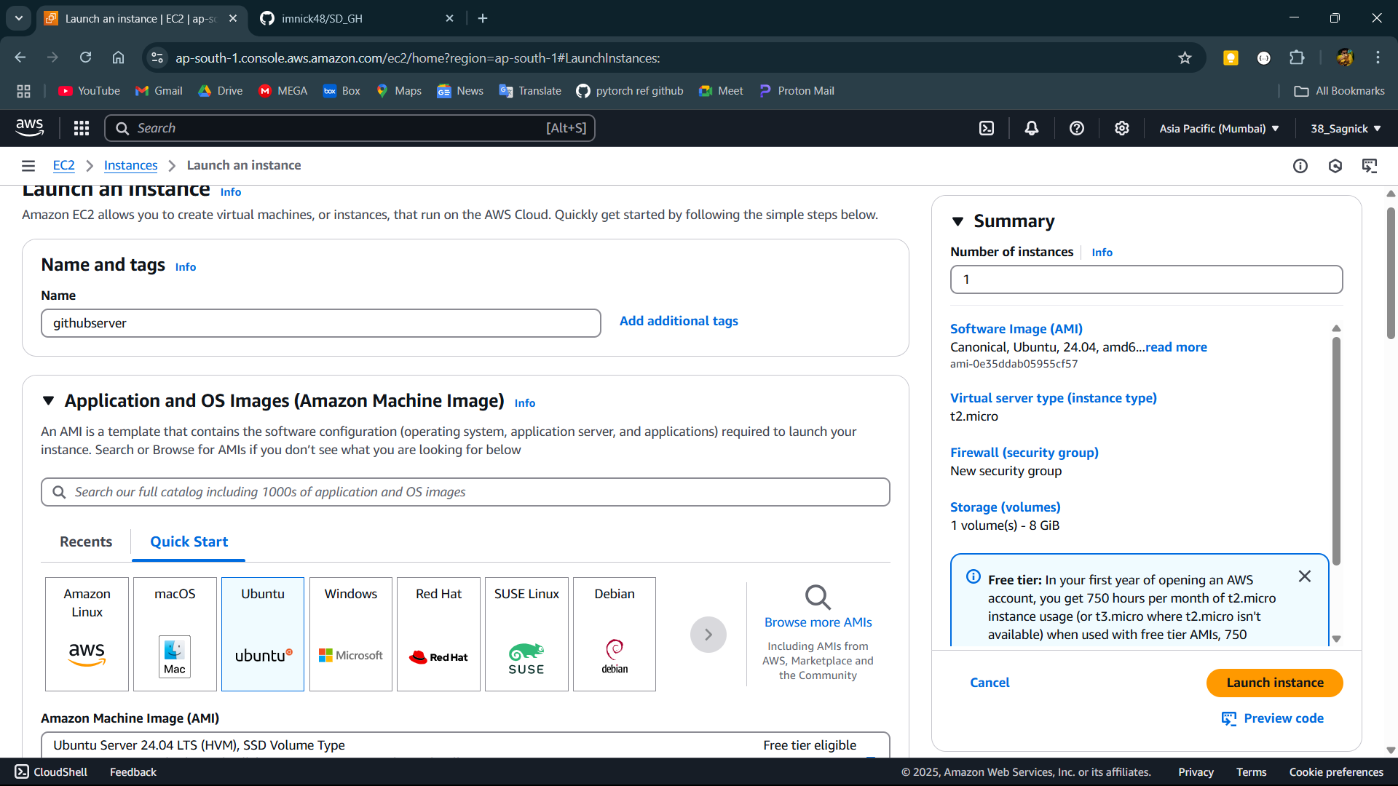

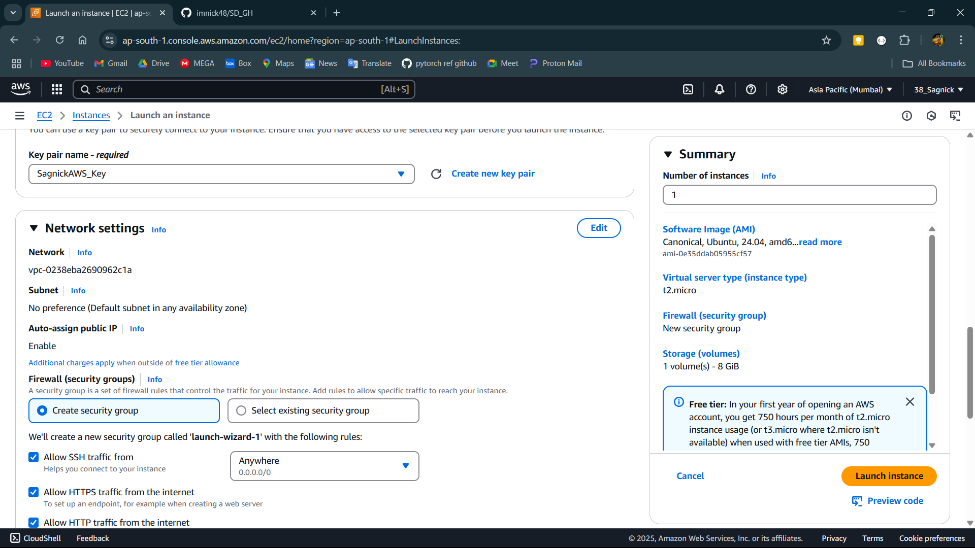

**Step-8:**

Now open instances and click of the instance Id of the instance.

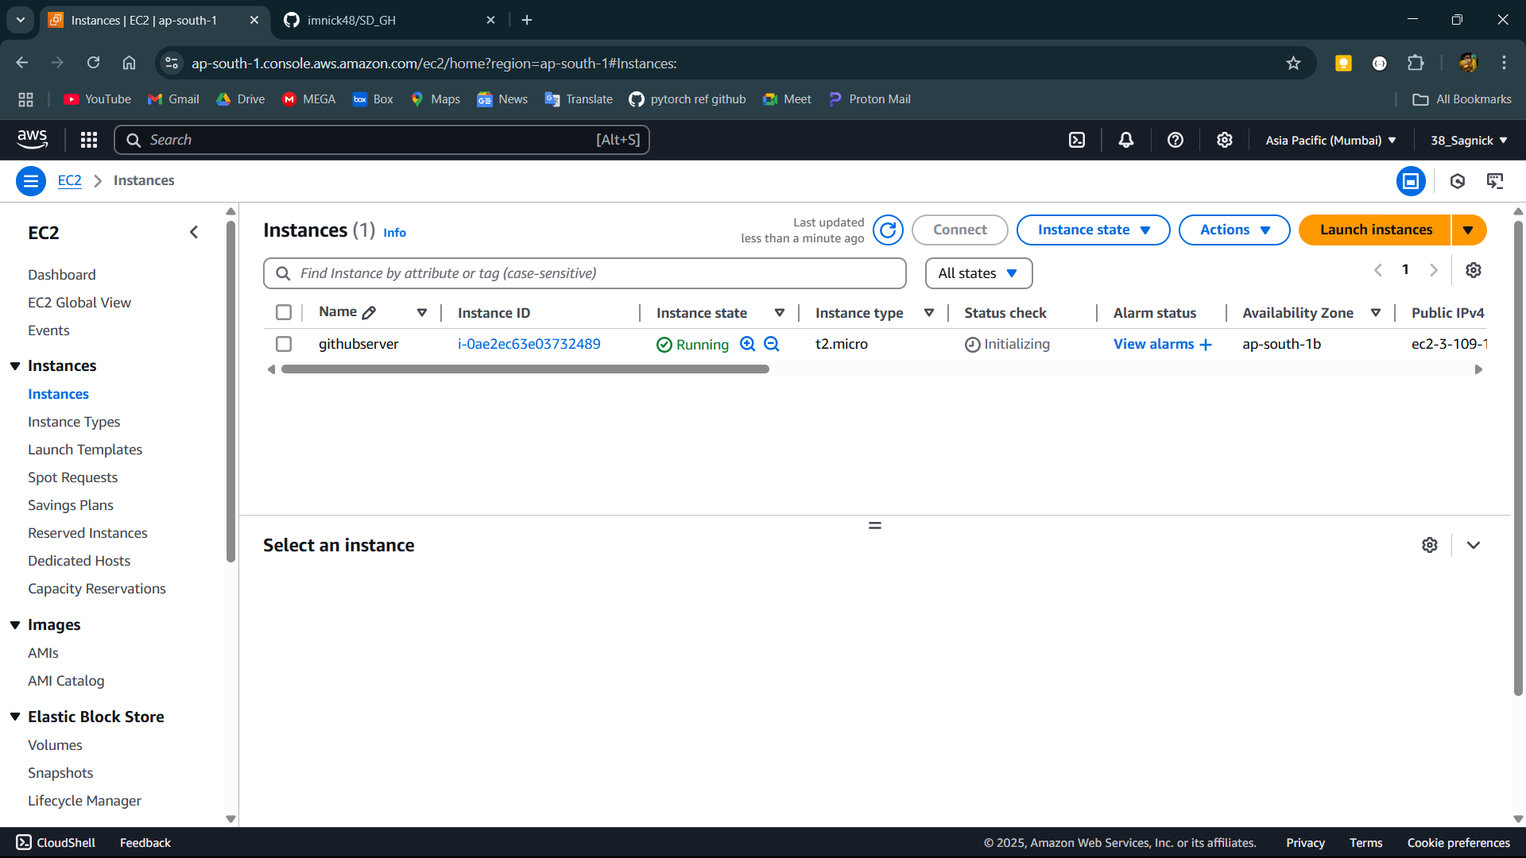

**Step-9:**

Copy the IPv4 address.

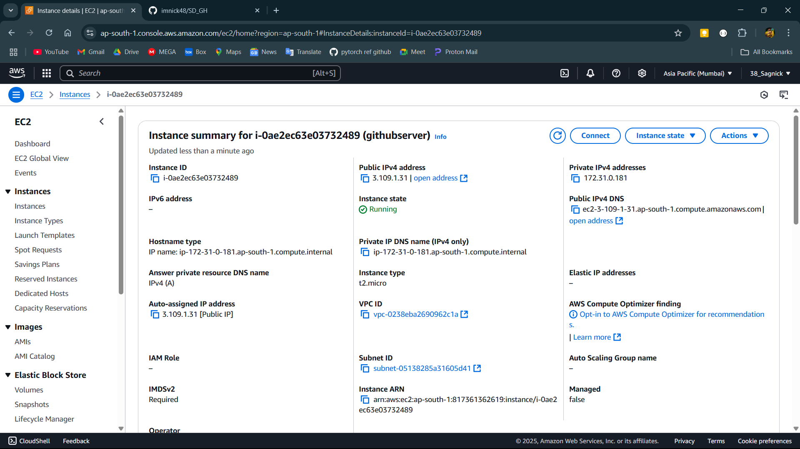

**Step-10:**

open bitvise client and paste the ip in host and set up authentication using the key pair then login and after logging in open new terminal window.

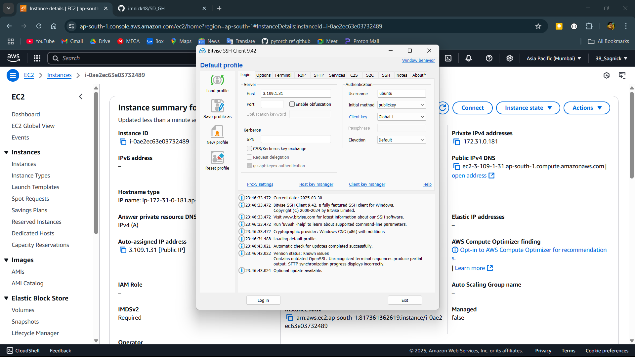

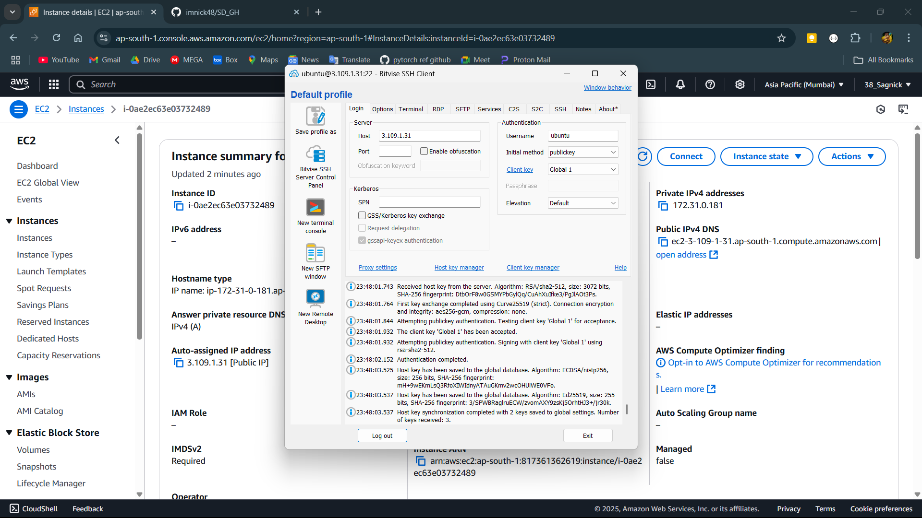

**Step-11:**

Then set up the instance using command sudo apt-get update and sudo apt-get upgrade.

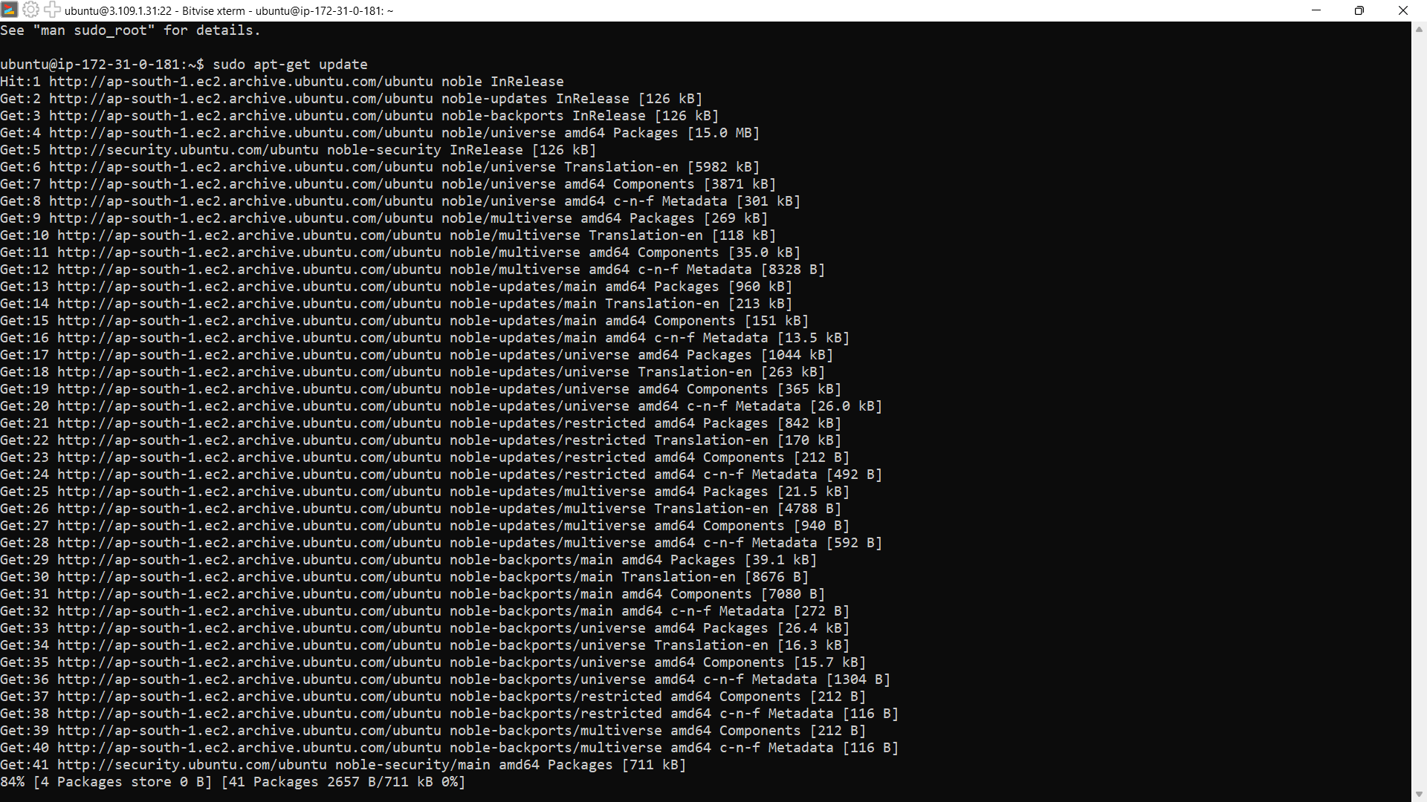

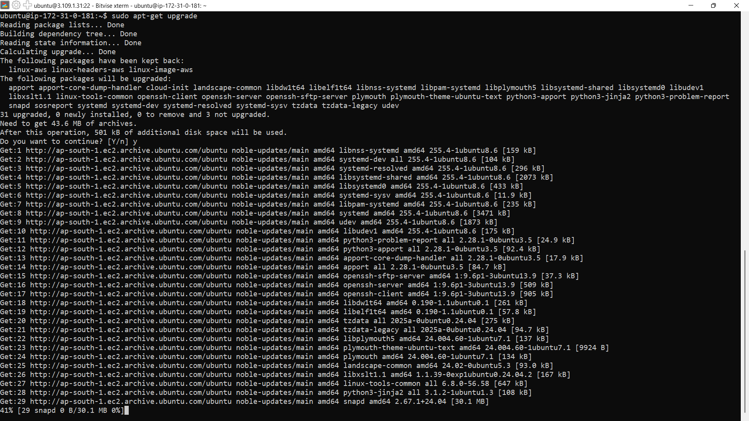

**Step-12:**

Now install nginx for setting up the web server.

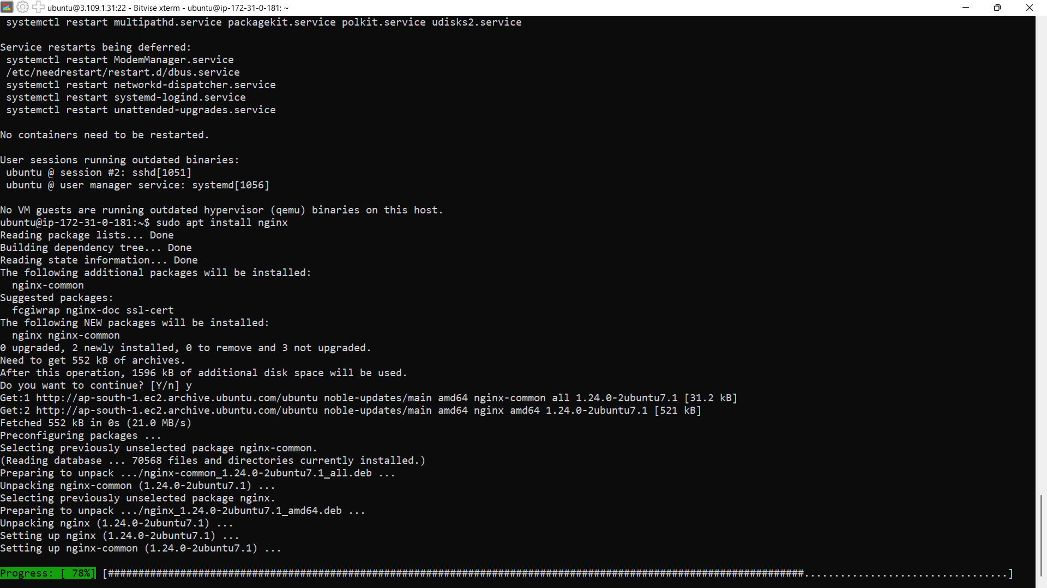

**Step-13:**

Now clone the github repository from github using command git clone paste the link of the repository.

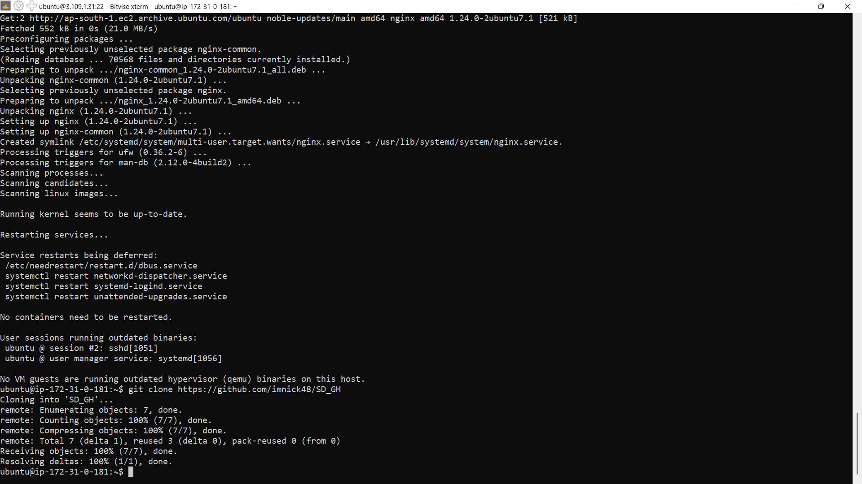

**Step-14:**

Then open the directory that is cloned using command cd name of the directory. Then install nodejs using commands curl -sL https://deb.nodesource.com/setup_18.x | sudo -E bash – and sudo apt-get install nodejs.

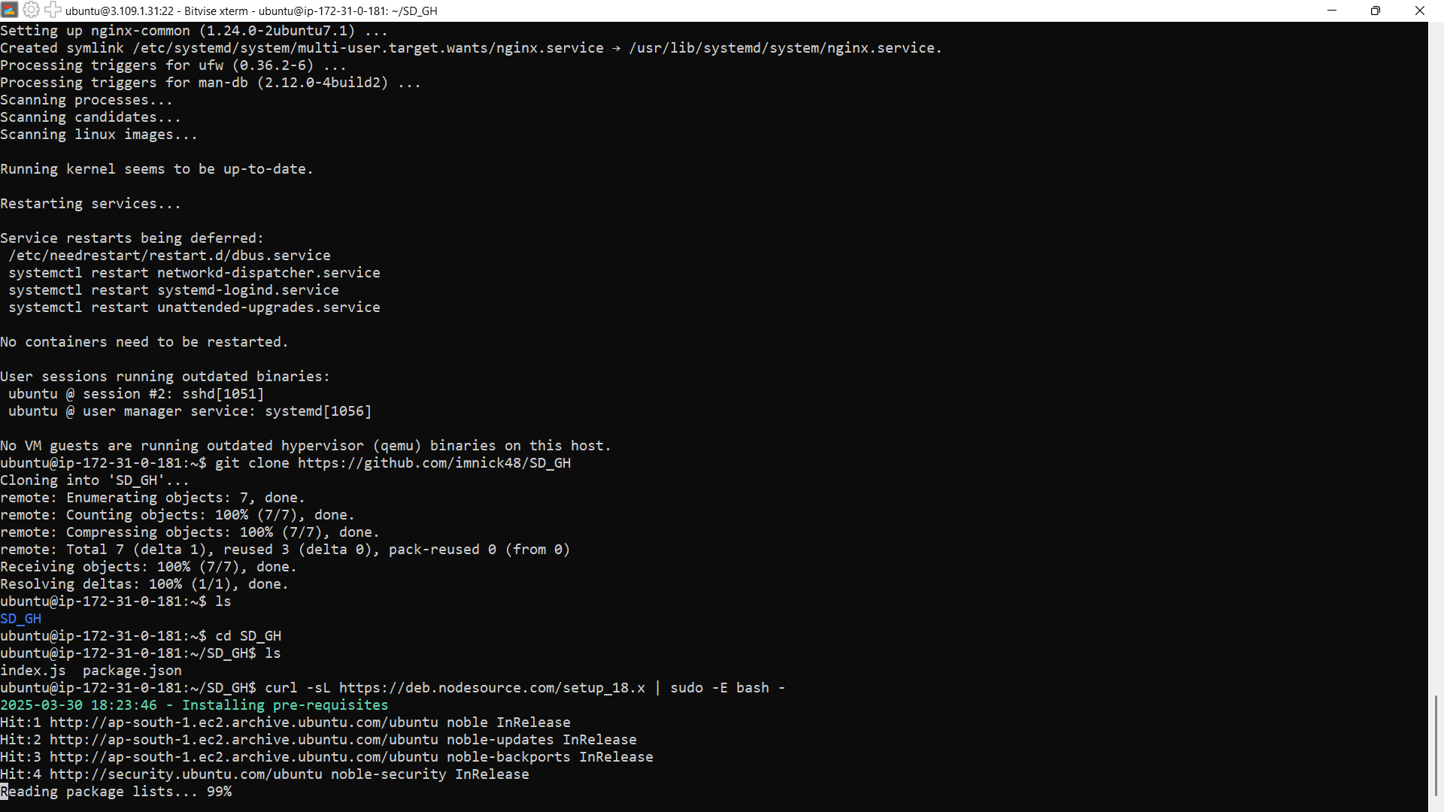

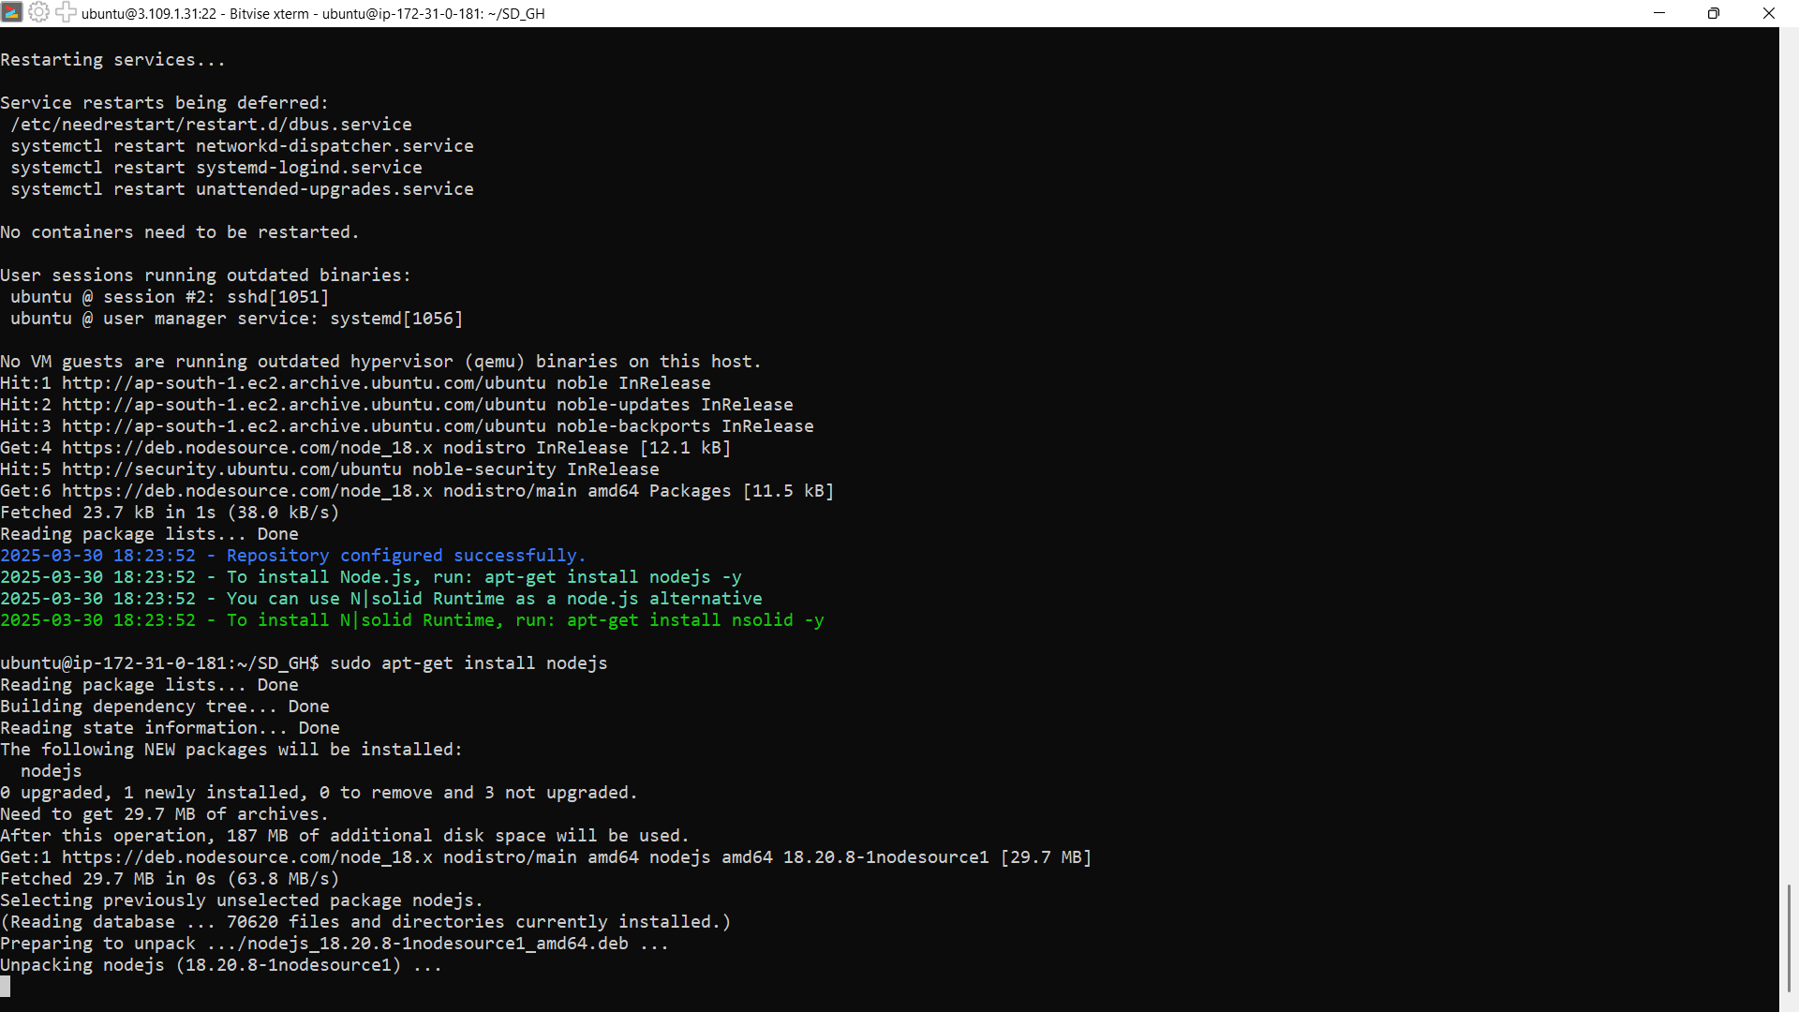

**Step-15:**

After installing nodejs use npm install command to install required dependencies.

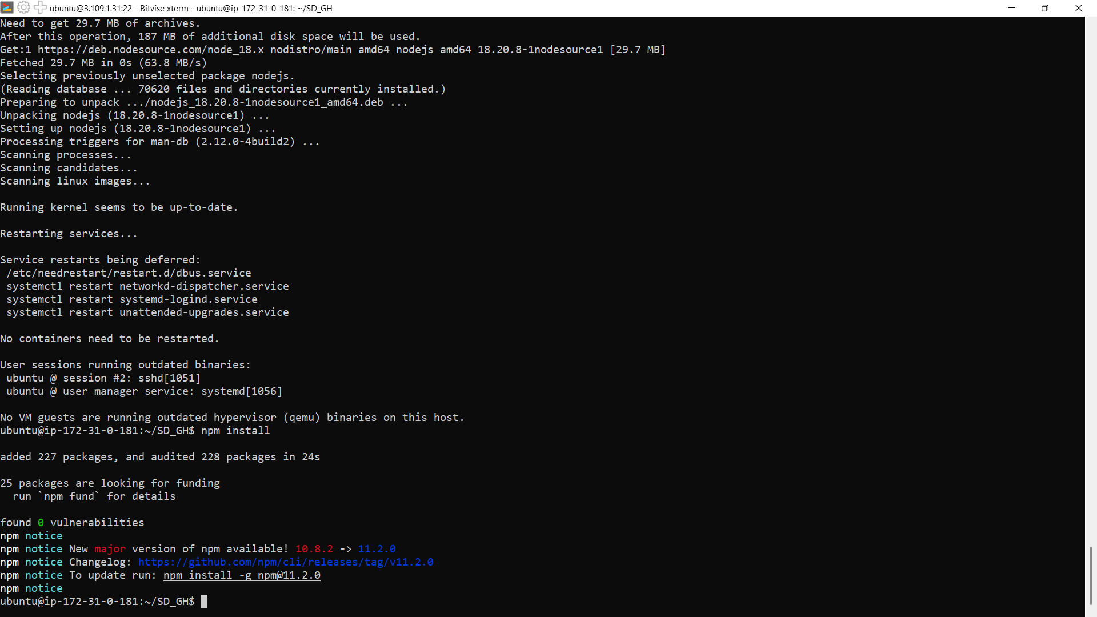

**Step-16:**

Now open aws and open the current instance then scroll down and goto security.

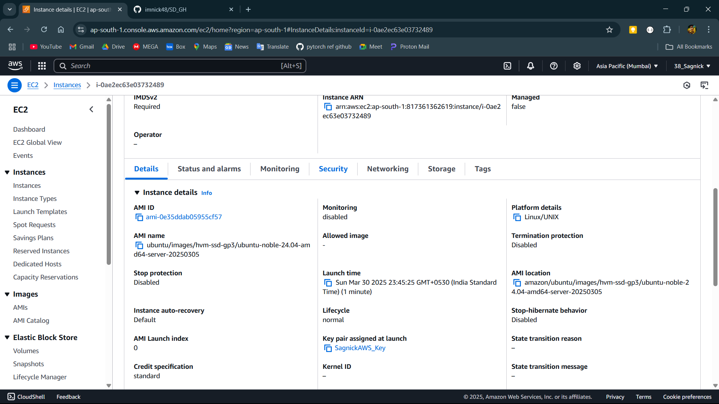

**Step-17:**

Then click on the link in security groups then click on edit inbound rules.

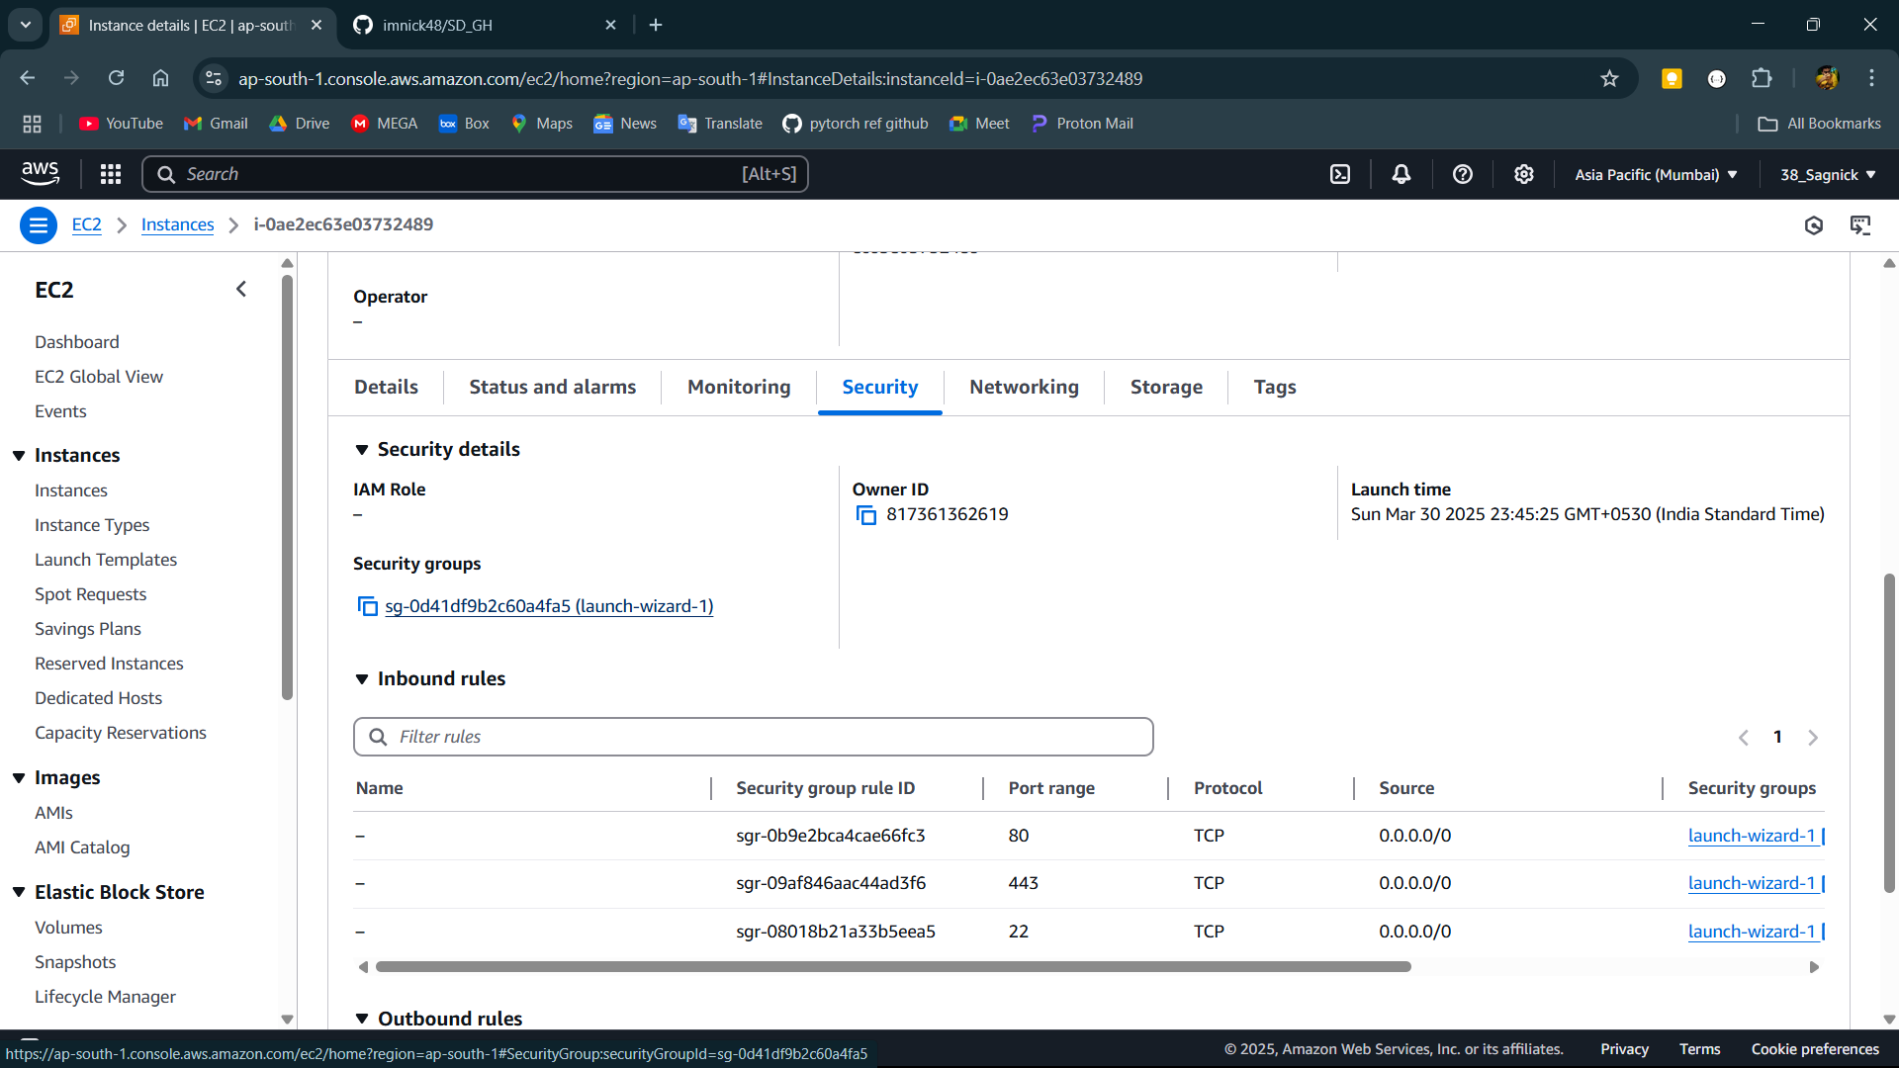

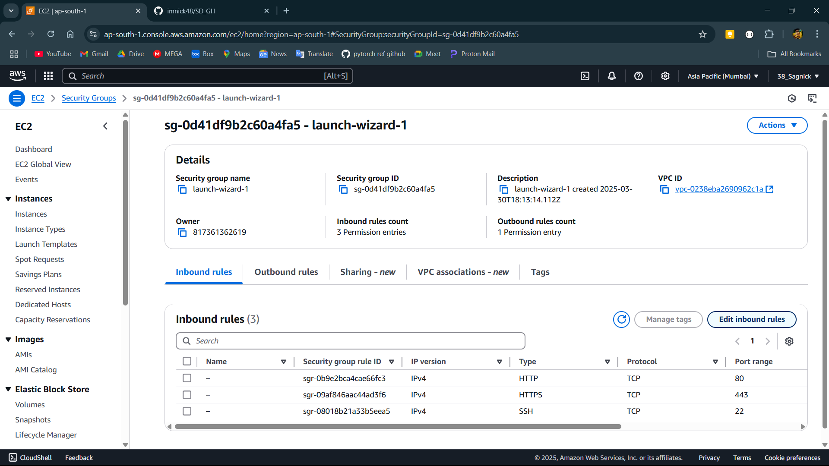

**Step-18:**

Click on add rule and select the type of new rule custom tcp port range 4000 source 0.0.0.0 or anywhere then click on save rule.

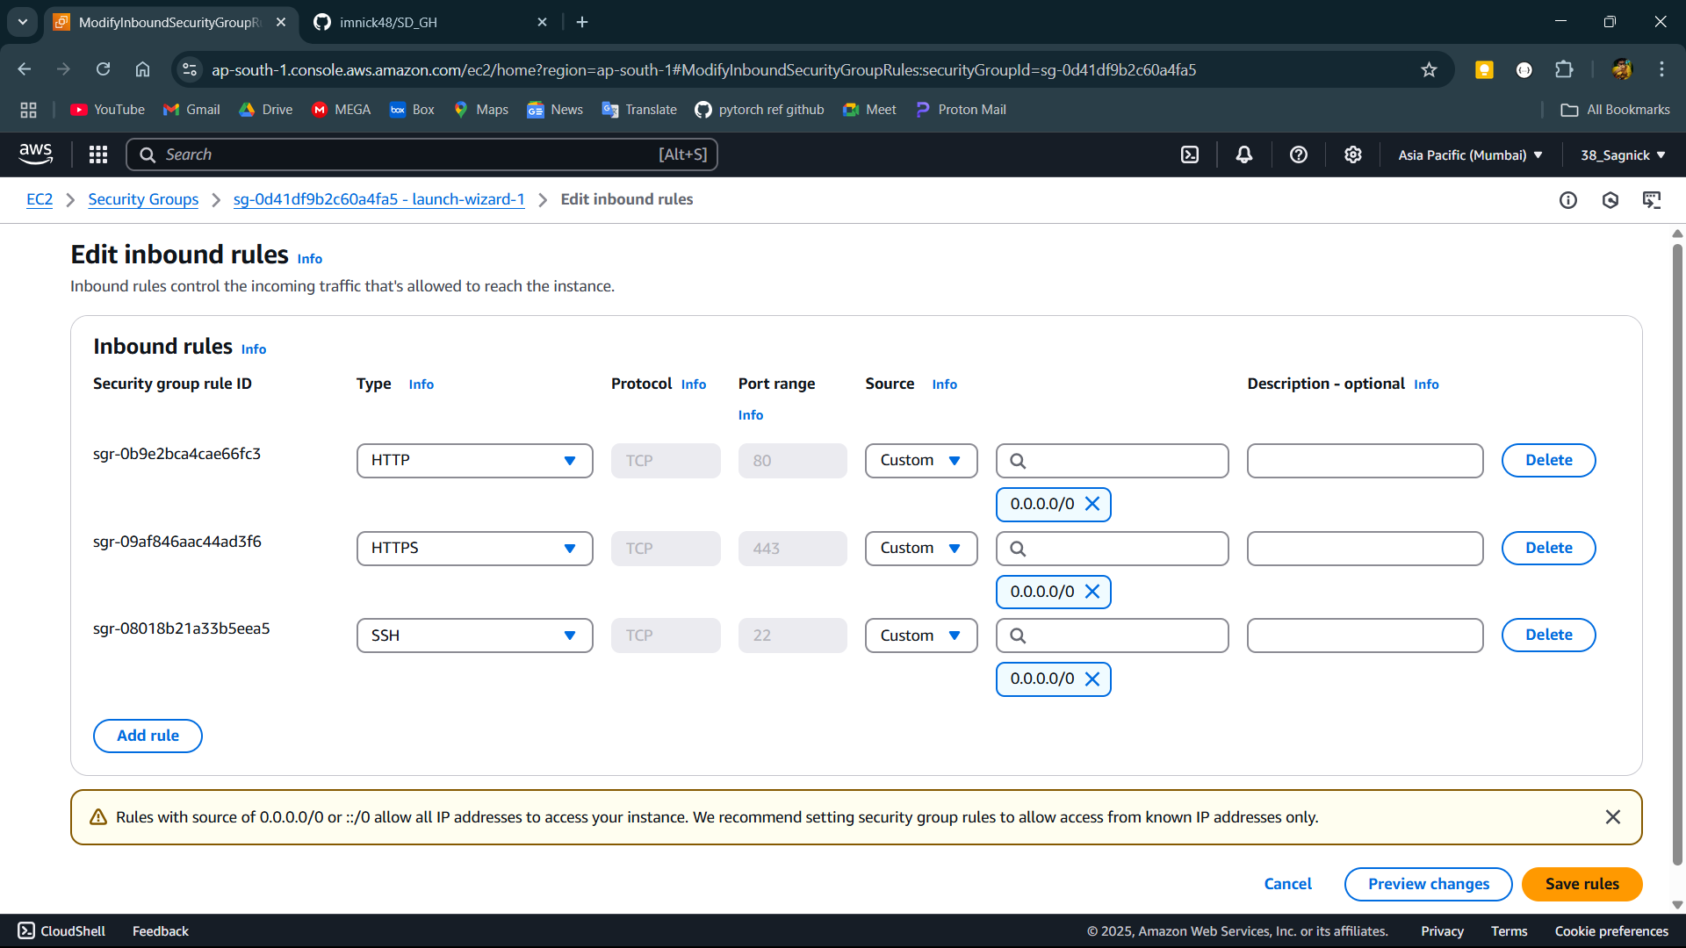

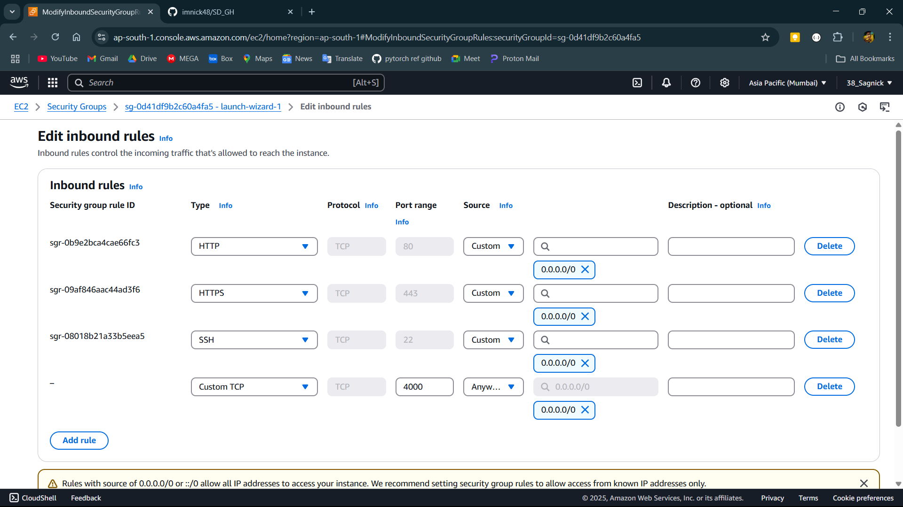

**Step-19:**

Open the terminal console and start the server using command node index.js .

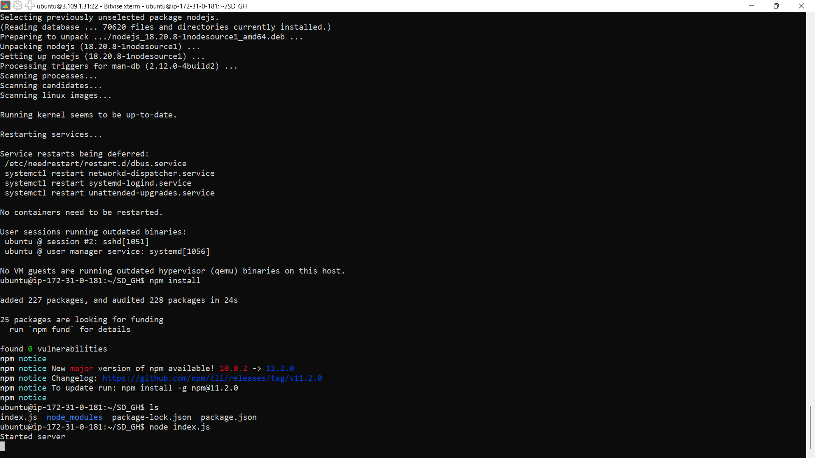**Step-20:**

Now copy the IPv4 address of the instance and paste it and the put the port like this IP address:Port here IP address:4000 .

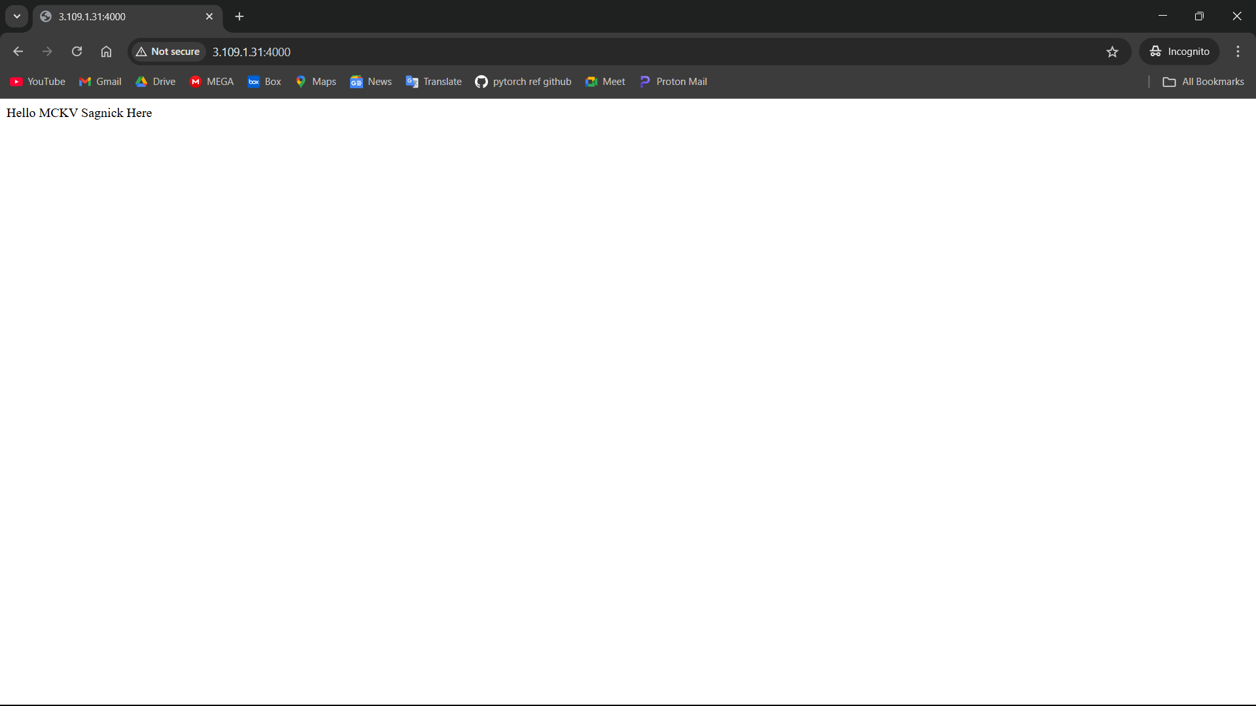

**Step-21:**

Incase of change in the file in github run the git pull command to update it here.

